


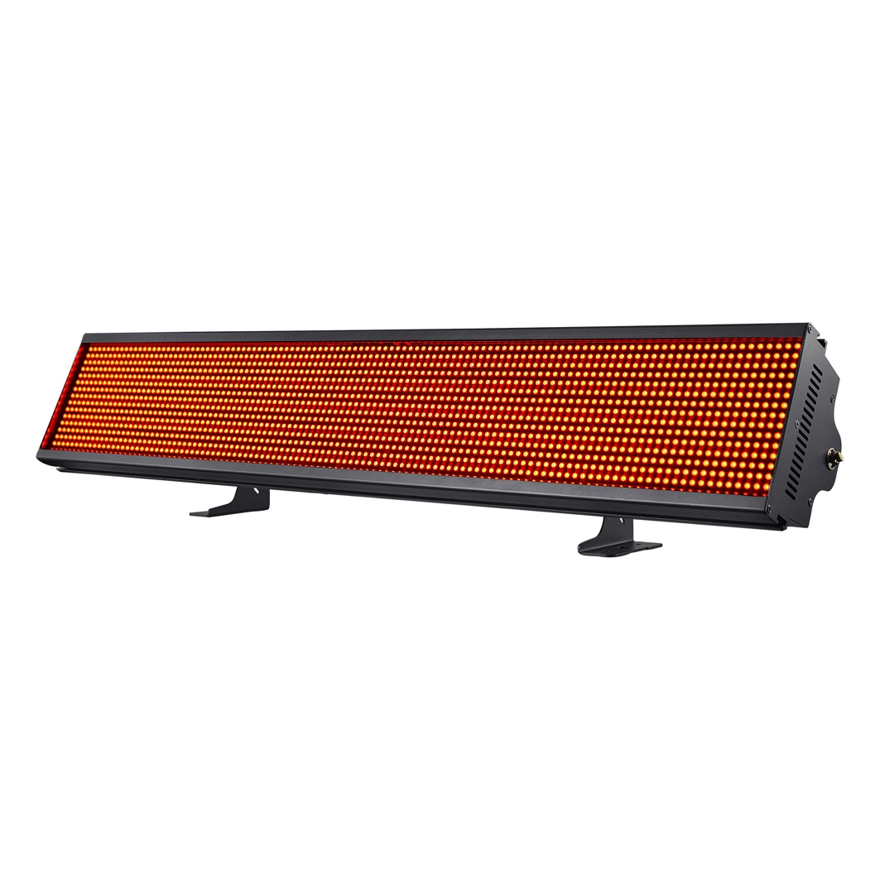

USER MANUAL
Table Of Contents

01/ Introduction / Safety Instructions ................................................
02/ Maintenance & Installation ...........................................................
04/ Display & Operation ......................................................................
05/ Main Functions ..............................................................................
08/ DMX Channel Chart ......................................................................
10/ Troubleshooting & Maintenance .................................................
12/ Technical Specifications ...............................................................
13/ Warranty .........................................................................................


PLEASE READ INSTRUCTIONS BEFORE USE

CAUTION

- INTRODUCTION
Thank you for choosing the Acue Lighting Storm Pix 700. To use this product correctly and safely, please read the instructions carefully before installing and using this product. This manual contains important installation and operation information. Make sure to strictly follow the instructions when installing and operating this product. Retain this manual in a safe place for future reference.
The Storm Pix 700 uses a high-temperature resistant aluminum/metal body with hard plastic covers and is IP19 rated. IP19 is a classification given to devices that are designed mostly for indoor use in cool dry areas. This product is designed and produced in strict accordance with CE standards and conforms to the international standard of DMX512 signal protocol. It can be controlled manually from the display or by DMX using the built in 3-pin XLR in/out connectors. This fixture is suitable for various types of indoor concerts, indoor events, indoor installations, and other like environments.

2. SAFETY INSTRUCTIONS
- Please keep this User Manual for future reference. All users of this fixture must read the user manual thoroughly.
- Unpack and check contents carefully to make sure there is no damage caused by shipping before using the unit.
- Before operating, ensure that the voltage and frequency of power supply match the power requirements of the unit.
- It’s important to properly ground the fixture to avoid electric shock.
- The unit is designed for indoor use. It is alright to use outdoors temporarily but not when moisture is present. Do not point fixture directly into sunlight. Make sure main power connector is connected to an outlet that is not near liquids or moisture.
- The unit must be installed in a location with adequate ventilation, at least 50cm from adjacent surfaces. Be sure that no ventilation slots are blocked.
- Disconnect main power before moving fixture.
- Make sure there are no flammable materials close to the unit while operating, as it is fire hazard.
- Use safety cable when mounting this unit.
- Do not connect this product to power dimmers.
- Max ambient operating temperature is 40˚C. Do not operate if the temperature is higher than this.
- Unit surface temperature may reach up to 85˚C. Do not touch the housing bare-handed during its operation. Turn off the power and allow about 15 minutes for the unit to cool down before replacing or serving.
- In the event of serious operating problem, stop using the unit immediately. Never try to repair the unit by yourself. Repairs carried out by unskilled individuals can lead to further damage or malfunction. Please contact the nearest authorized technical assistance center. Always use the same type of parts.

3. Maintenance and Installation
3.1 Maintenance
- To reduce the risk of electrical shock or fire, do not expose the power cable connector of this unit to rain or moisture.
- Intermittent usage will extend this fixtures service life.
- Please clear the fan, fan net, and optical lens of any dust or obstructions in order to keep the fixture in a proper working state.
- Do not use alcohol or any other organic solvent to wipe the shell.

3.2 Statement
All fixtures have been tested thoroughly before leaving the factory. In order to keep the product in good condition and ensure safe operation, users should follow the safety precautions and warnings in this manual.

Important: Damages caused by not following the guidelines in this user manual are not covered under warranty. The manufacturer is not responsible for product issues caused by misuse.

3.3 Safety Precaution
- In order to guarantee the product’s life expectancy, do not store or use in environments over 60˚ C.
- Always mount this unit in a safe and stable manner. Mounting system must be able to withstand 10x that of the fixture’s weight. A safety cable must always be used as a secondary source for securing the fixture.
- Installation of this fixture may only be carried out by skilled individuals.
- This product can be used in the voltage range of 90-240V and is an indoor rated product. Please make sure that the power mains voltage used is not higher/or lower than what the product can withstand! The power plug must be inserted into a protected Class I socket and must be grounded properly.
- In order to make sure the product is used properly, please read this manual carefully.

3.4 Cable connection (DMX)
Make sure to use a cable conforming to specifications EIA RS-485: 2-pole twisted, shielded, 120Ohm characteristic impedance, 22-24 AWG, Low capacity. Do not use microphone cable or other cable with characteristics differing from those specified. The end connections must be made using XLR type 3-pin/ 5-pin male/female connectors. A terminating plug must be inserted into the last fixture with a resistance of 120 Ohm (minimum 1/4 W) between terminals 2 and 3.
IMPORTANT: The wires must not make contact with each other or with the metal casing of the connectors. The casing itself must be connected to the ground of the connector plugs.

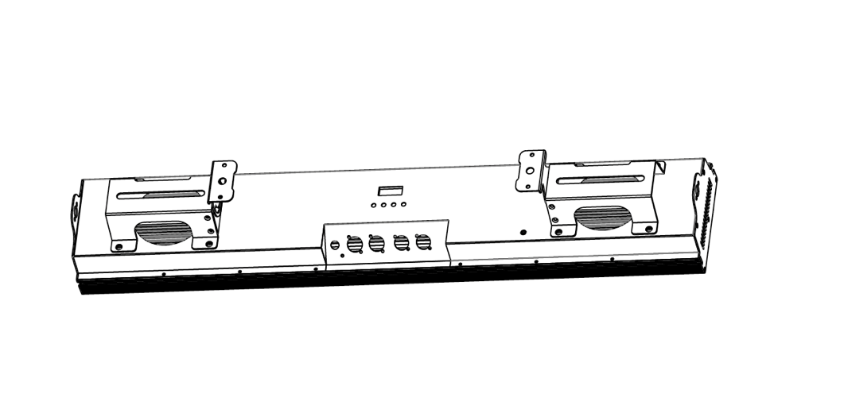
4. Display & Operation
1. Display | Used to show the various menus and the selected function
2. Buttons | MENU | Enter into / move backward or leave the menu
2. Buttons | UP | Go backward / move up in the menu
2. Buttons | DOWN | Go forward / move down in the menu
2. Buttons | ENTER | Perform the selected function / Save
3. FUSE
4. POWER IN | Powercon Power Input
5. POWER OUT | Powercon Power Output/Link
6. DMX OUT | For DMX512 link, use 3-pin XLR cable to link the next units to output DMX signal (5-pin XLR cable is optional)
7. DMX IN | For DMX512 link, use 3-pin XLR cable to link the unit and DMX controller to input DMX signal (5-pin XLR cable is optional)

4. 1 Main Functions
- To access the control menus, press the [MENU] button.
- Navigate the menu structure, using the [ENTER], [ UP] and
[ DOWN] buttons.
- To select a menu option or to confirm a selection, press the [ENTER] button. 4 To return to a higher level in the menu structure without making a change, press the [MENU] button, or wait 30 seconds.

The screen will automatically lock if there is no operation for a long time, and can be unlocked by long-pressing [MENU] button.

MENU | SUBMENU | 3RD Meny | Default Value
Address | 001-512
System setting | Working mode | DMX
System setting | Working mode | Sound
System setting | Working mode | Auto 1
System setting | Working mode | Auto 2
System setting | Channel mode | 17CH/178CH
System setting | Pixel Inversion | ON/OFF
System setting | Singal Remain | ON/OFF
System setting | Screen Flip | On/Off/Auto
System setting | Synchronize | On/Off
System setting | Language | 中文/English
System setting | Dimming speed | Standard/Fast
System setting | Reset | Yes/No
Manual | 17CH/178CH | 000-255
Calibration | PASSWORD

DMX Setting
Enter the control menu and select DMX Setting, press ENTER. Use the UP/DOWN button to select DMX Address, Ethernet Setup or Connect Option.

DMX Address
Select DMX Address, press ENTER.
Use UP/DOWN button to select an address, confirm your selection with ENTER.
CHANNEL MODE | DMX ADDRESS
17 Channel | 1-496
178 Channel | 1-335
To exit the menu, press Menu.

Function | Description
Working mode | Working mode: DMX/Sound /Auto 1/Auto 2
Working mode | DMX mode | Console mode, receiving DMX signals
Working mode | Auto 1 | Fixture runs automatically by auto 1
Working mode | Auto 2 | Fixture runs automatically by auto 2
Working mode | Sound | When the light fixture detects strong sound, it automatically runs a scene according to the built-in program, otherwise it maintains the last scene
Channel mode | 17CH / 178CH
Pixel Inversion | Set pixel direction
Pixel Inversion | OFF | No Reverse
Pixel Inversion | ON | Reverse
Singal Remain | When there is no DMX signal, the output status of the lighting fixture
Singal Remain | OFF
Singal Remain | ON | Keep the last DMX data output
Screen back. L | Screen brightness duration
Screen back. L | OFF | Always ON
Screen back. L | ON | Screen is timed to turn off
Screen Flip | Display direction setting
Screen Flip | OFF | No reverse display
Screen Flip | ON | Reverse display
Screen Flip | AUTO | Automatically
Synchronized update | Synchronize the setting parameters or calibration parameters of multiple lighting fixtures
Synchronized update | OFF
Synchronized update | ON

CHANNEL | VALUE | FUNCTION
1 | 000-255 | Master dimmer 0 – 100%
2 | 0-7 | Shutter Closed
2 | 8-15 | Shutter Open
2 | 16-131 | Ramp up
2 | 132-139 | Shutter Open
2 | 140-181 | Ramp down
2 | 182-189 | Shutter Open
2 | 190-231 | Ramp Up → Ramp Down
2 | 240-247 | Random
2 | 248-255 | Shutter Open
3 | 000-255 | Red from 0 – 100%
4 | 000-255 | Green from 0 – 100%
5 | 000-255 | Blue from 0 – 100%
6 | 000-255 | CW from 0 – 100%
7 | 000-255 | WW from 0 – 100%
8 | 000-255 | Macro
9 | 000-255 | RGB Effect
10 | 000-255 | RGB Effect speed
11 | 000-255 | RGB Fade
12 | 000-255 | Cool White effect
13 | 000-255 | Cool white effect speed
14 | 000-255 | Cool white fade
15 | 000-255 | Warm white effect
16 | 000-255 | Warm white effect speed
17 | 000-255 | Warm white fade
5. DMX Channel Charts
17 Channel Mode

178 Channel Mode:
CHANNEL | VALUE | FUNCTION
1 | 000-255 | Master dimmer 0 – 100%
2 | 0-7 | X
2 | 8-15 | Shutter
2 | 16-131 | Ramp up
2 | 132-139 | Shutter
2 | 140-181 | Ramp down
2 | 182-189 | Shutter
2 | 190-231 | Ramp Up → Ramp Down
2 | 240-247 | Random
2 | 248-255 | Shutter
3 | 000-255 | Red 1 from 0 – 100%
4 | 000-255 | Green 1 from 0 – 100%
5 | 000-255 | Blue 1 from 0 – 100%
6 | 000-255 | Red 2 from 0 – 100%
7 | 000-255 | Green 2 from 0 – 100%
8 | 000-255 | Blue 2 from 0 – 100%
9 | 000-255 | Red 3 from 0 – 100%
… | … | …
96 | 000-255 | Red 32 from 0 – 100%
97 | 000-255 | Green 32 from 0 – 100%
98 | 000-255 | Blue 32 from 0 – 100%
99 | 000-255 | Cool White 1 from 0 – 100%
100 | 000-255 | Cool white 2 from 0 – 100%
… | … | …
144 | 000-255 | Cool White 46 from 0 – 100%
145 | 000-255 | Cool white 47 from 0 – 100%
146 | 000-255 | Cool White 48 from 0 – 100%
147 | 000-255 | Warm white 1 from 0 – 100%
148 | 000-255 | Warm white 2 from 0 – 100%
149 | 000-255 | Warm white 3 from 0 – 100%
150 | 000-255 | Warm white 4 from 0 – 100%
151 | 000-255 | Warm white 5 from 0 – 100%
152 | 000-255 | Warm white 6 from 0 – 100%
153 | 000-255 | Warm white 7 from 0 – 100%
154 | 000-255 | Warm white 8 from 0 – 100%
155 | 000-255 | Warm white 9 from 0 – 100%
… | … | ...
176 | 000-255 | Warm white 30 from 0 – 100%
177 | 000-255 | Warm white 31 from 0 – 100%
178 | 000-255 | Warm white 32 from 0 – 100%

6. Troubleshooting & Maintenance
Error codes are shown continuously in the display when the fixture fails, and they will not disappear until the fixture is repaired.

6.1 Error Monitoring
Temp. Error
-Check if the thermostat is normal. Check whether the components of the temperature detecting board are damaged.
-Check if the lead on the temperature detecting board is disconnected.
Fan 1/2/3/4 Error
-Check if the fan is not running.
-Check if the fan leads are disconnected.
C-heck if the fan is damaged.
-Check if there are obstacles in the fan operating range. Check whether the fan circuit on the motherboard breaks down.
-Check if the component is damaged.
-Check if the fan is out of order.
6.2 Troubleshooting

Following are a few common problems that may occur during operation. Here are some suggestions for troubleshooting:
A. The unit does not work, no light and the fan does not work
- Check the connected power.
- Measure the voltage.
- Check the power indicator to see if it can be lit up or not.
B. Not responding to the DMX controller
- Check if the DMX connectors and the DMX cables are connected correctly.
- Check if the DMX address is correctly set.
- If the intermittent DMX signal problem occurs, check if the XLR socket and the signal cable are well connected.
- Try it with another DMX controller.
- Check if the DMX cables run near or alongside to the high-voltage cables, which may damage or interfere with the signal circuit.

6.3 Maintenance

It is essential that the fixture is kept clean to ensure the maximum light-output and allow the fixture to function reliably throughout its life. The fixture must be cleaned regularly to avoid dust, dirt and smoke-fluid residues building up on or within the fixture. The cleaning frequency depends on the application environment. Clean the fixture immediately if the dust enters it to avoid damage to the optical lens due to excessive dust.
- A soft lint-free cloth moistened with any good glass cleaning fluid is recommended, under no circumstances should solvents be used.
- Always dry the parts carefully.
- Clean the external optical lens at least every 20 days.

7. Technical Specifications

Power Input Voltage | 100-240V～50/60Hz
Power Consumption | 700W Max
Light Source | 1792pcs 0.2W RGB LEDs,224pcs 1W Warm White LEDs,336pcs 0.3W Cool White LEDs
Beam Angle | 120˚
Dimmer/Strobe | 0-100% smooth dimming；high output strobe effect
Control | DMX Channels | 17CH
Control | DMX Channels | 178CH
Control | Control Modes | DMX512
Control | Control Modes | RDM
Control | Control Modes | Master/Slave
Control | Control Modes | Manual
Control | Firmware Update | Firmware update via DMX link
Construction | Display | LCD display
Construction | Data IN/Out | 3-pin XLR
Construction | Power In/Out | Powercon IN & OUT
Features | Variable 16-bit dimming modes and curves
Features | High output blinder mode or constant output mode
Features | Outstanding color mixing effect
Dimensions | 100x24x18cm (single unit with handle) 40”x 9.5”x 7”
Weight | 6.8kg/ 15 lb.

8. Warranty
This product carries a 1-year manufacturer’s warranty which covers factory defects or internal issues not caused by the owner/operator of the fixture. Misuse, physical damage, or any other issues caused by misuse by the customer are not covered under manufacturer’s warranty. All warranty claims must be handled directly through the manufacturer and not the dealer. Original sales receipt required for all warranty claims. Submit all claims to Info@Acueligthing.com.

For more information about this product as well as all our other products please visit:
www.AcueLighting.com
Or contact us directly:
Email: Info@AcueLighting.com
Phone: (818) 646-7526/ (818) 672-6822

