

Extreme 350

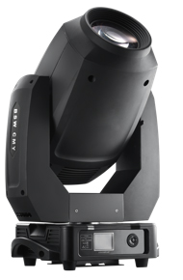

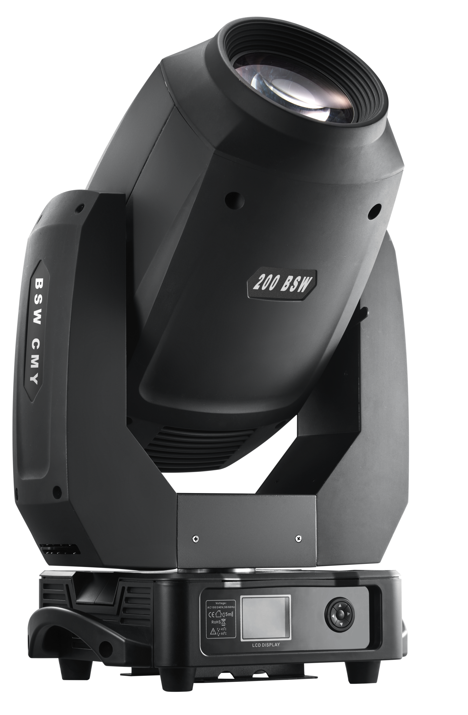

USER MANUAL

Ver:1.0

Extreme 350

Table of contents

- Safety instructions..................................................................................... 3

- Operating Instructions........................................................................... 4

- Fixture exterior view ................................................................................. 5

- Installation ................................................................................................ 6

4.1 Connection to the mains............................................................... 6

4.2 Replacing gobos ........................................................................... 7

4.3 Rigging the fixture......................................................................... 8

4.4 DMX-512 connection..................................................................... 10

5. Control menu map.................................................................................... 11

- Technical Specifications................................................................................ 13

- Maintenance and cleaning.............................................................................. 16

- Photometric diagram....................................................................................... 17

- DMX protocol................................................................................................... 18

CAUTION!

Keep this device away from rain and moisture!

Unplug from power before opening the housing!

FOR YOUR OWN SAFETY, PLEASE READ THIS USER MANUAL CAREFULLY

BEFORE YOUR INITIAL START - UP!

1. Safety instructions

Every person involved with installation and maintenance of this device has to be:

- A qualified technician

- Able to follow the instructions in this manual

CAUTION!

Use cautions when operating.

High voltage is in use and can cause

a dangerous electric shock when touching power lines!

This device has left our premises in absolutely perfect condition. In order to maintain this condition and to ensure a safe operation, it is absolutely necessary for the user to follow the safety instructions and warning notes written in this manual.

Important:

The manufacturer will not accept liability for any resulting damages caused by the non-observance of this manual or any unauthorized modification to the device.

Please consider that damages caused by manual modifications to the device are not subject to warranty.

Never let the power-cord come into contact with other cables! Handle the power cord and all connections with the mains with particular caution!

Make sure that the available voltage is not higher than stated on the rear panel.

WARNING! Always disconnect power input cable to completely remove power from unit when not in use or before cleaning or servicing the unit.

Make sure that the power cord is never crimped or damaged by sharp edges. Check the device and the power cord from time to time.

Always disconnect from the mains when the device is not in use or before cleaning it. Only handle the power cord by the plug. Never pull out the plug by tugging the power cord.

This device falls under protection class I. Therefore it is essential to connect the ground conductor to earth. All electric connections, repairs and servicing must be carried out by a qualified technician.

Do not connect this device to a dimmer pack.

During the initial start-up some smoke or smell may arise. This is a normal process and does not necessarily mean that the device is defective.

Do not touch the device’s housing with bare hands during its operation (housing becomes hot!) For replacement of fuses you must use same type and rating only as the fuse inside the fixture.

Warning! Risk Group 2 LED product according to EN 62471. LED light emission. Risk of eye injury!

Do not look straight at the fixture´s LED source during operation. The intense light beam may damage your eyes.

Do not view the light output with optical instruments or any device that may concentrate the beam.

2. Operating Instructions

This device is a moving head for creating decorative effects and was designed for indoor use only. This device is for professional use only. It is not for household use.

If the device has been exposed to drastic temperature fluctuation (e.g. after transportation), do not switch it on immediately. The arising condensation or water might damage your device. Leave the device switched off until it has reached room temperature.

Do not shake the device. Avoid brute force when installing or operating the device.

Never lift the fixture by holding it at the projector-head, as the mechanics may be damaged. Always hold the fixture by using the transport handles.

When choosing the installation spot, please make sure that the device is not exposed to extreme heat, moisture or dust.

Make sure that the area below the installation location is blocked when rigging, removing or servicing the fixture.

Always attach the fixture with an appropriate safety cable. Attach the safety cable to the correct holes only.

Only operate the fixture after having checked that the housing is firmly closed and all screws are tightly fastened.

The maximum ambient temperature of 45°C must never be exceeded.

CAUTION!

The lens has to be replaced when cracks or damage is present.

Operating with damaged lens can cause lens to break during operation.

Operate the device only after having familiarized with its functions. Do not permit operation by person(s) not qualified for operating the device. Most damages are the result of unprofessional operation or negligence!

Do not block the front objective lens with any object when the fixture is under operation.

The fixture housing must never be covered with cloth or other materials.

Please use the original packaging or a travel/road case designed for the fixture if the device is to be transported.

Please consider that unauthorized modifications on the device are forbidden due to safety reasons!

If this device will be operated in any way different to the one described in this manual, the product may suffer damages and the guarantee/warranty becomes void. Furthermore, any other operation may lead to dangers like short-circuit, burns, electric shock, fire etc.

CAUTION!

To avoid damage to internal parts of the fixture, never allow direct sunlight or other fixture lights to enter directly in the front lens, even when the fixture is not working!

3. Fixture exterior view
2

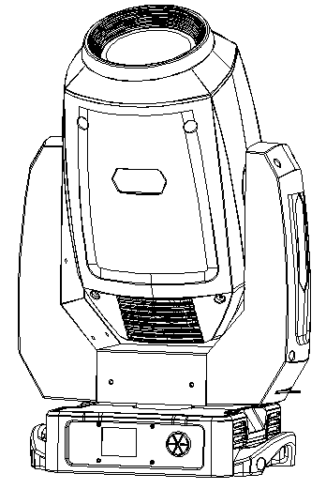
1

8
3
1 - Head

2 - Front lens

3 - Tilt lock

4 - Pan lock

5 - Handles

6 - Control buttons

7 - Display screen

8 - Yoke
4

5
5

6

7
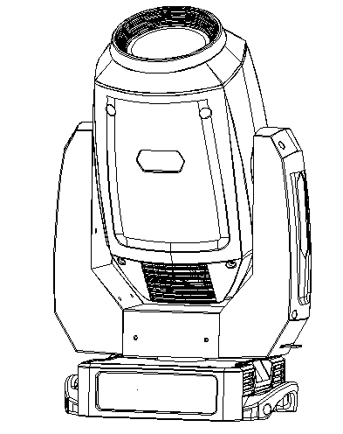

9 - Power (PowerCon)

10 - Fuse holder

11 - DMX OUT (3-pin)

11 - DMX IN (3-pin)

12 - DMX OUT (5-pin)

12 - DMX IN (5-pin)

13 - Switch

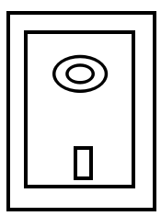
11




12

9
10
13

The head has to be locked for transportation- the tilt lock latch (3) and the pan lock latch (4) have to be in the locked positions. To unlock the head, move these latches to unlock positions before operating the fixture.

- Installation

Fixtures must be installed by a qualified electrician in accordance with all national and local electrical and construction codes and regulations.

4.1 Connection to the mains
oFor protection from electric shock, the fixture must always be grounded!

For protection from electric shock, the fixture must be grounded at all times!
The Extreme 350 is equipped with auto-switching power supply that automatically adjusts to any 50-60Hz AC power source from 100-240 Volts. The power cord is enclosed with the fixture. Install a suitable plug on the power cord if needed, Note that the wires in the power cord are colored according to the following table. The ground has to be connected! If you have any doubts about proper installation, consult a qualified electrician.
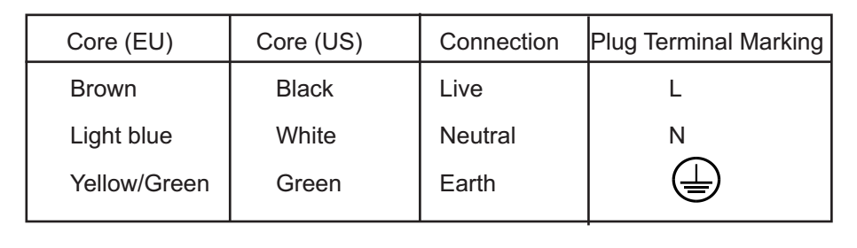

4.2 Replacing rotating gobos
DANGER!
Install the gobos with the fixture switched off only.
Unplug from mains before opening cover!

- Disconnect the fixture from mains and allow it to cool.
- Remove the plastic cover of the head by loosening the 4 quarter-turn fasteners on the cover.
- Gently pull up the gobo holder (3) from the rotation gobo wheel.
- Remove the spring lock (1) with an appropriate tool (e.g. small-bladed screwdriver) and remove it. Do not touch the surface of the pattern on the glass gobo with bare fingers.
5. Remove the original gobo (2) and insert the new one (glazy side towards the light source). The gobo has a small position point (8) at its edge, which has to be aimed at the position point (4) on the gobo holder (4). Insert the spring lock to secure correct gobo position in the gobo holder.
- Insert the gobo holder back under the distance slots (6, 7) into rotating gobo wheel in this way, that its position point (4) has is aimed at a small tooth-like mark (5) on the edge of the rotating gobo wheel.
Important! When inserting the gobo holder back on to the rotating gobo wheel, one of the adjacent gobo holders has to be oriented according to the same rule, it means that its position point (4) has to aimed at the tooth-like mark (5) on the edge of the rotating gobo wheel. You have to keep both marks (4) and (5) side by side when rotating the gobo wheel to the position to allow the inserting of the gobo holder.
- Replace the plastic cover before applying power.
- Use the Menu ->Service to fine adjust replaced gobo (Service -> Calibration -> Calibrate effects -> R. Gobo Index 1 ...R. Gobo Index 6).
Note. The magnet (9) of the gobo holder has the same function as the position point (4) on the rest of gobo holders.
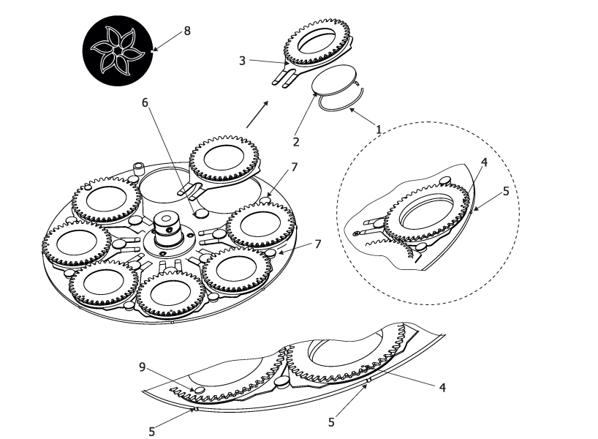
4.3 Rigging the fixture
The installation point of the fixture has to be built and constructed in a way that it can hold 10 times the weight for 1 hour without any harming deformation.

The mounting point must always be secured with a secondary safety attachment, e.g. an appropriate catch net. This secondary safety attachment must be constructed in a way that no part of the installation can fall down if the main attachment fails.

When rigging, removing or servicing the fixture stay clear of the area below the installation location.

The operator has to make sure that all safety-related and technical concerns are approved by an expert before operating for the first time and after changes have been made to the rigging point.

The operator has to make sure that an expert examines and approves all safety-related and technical aspects of the installation at least once a year.

The fixture should be installed outside areas where people may walk by or be seated in.

IMPORTANT! OVERHEAD RIGGING REQUIRES EXTENSIVE EXPERIENCE, including (but not limited to) calculating working load limits, installation material being used, and periodic safety inspection of all installation materials and the fixture. If you lack these qualifications, do not attempt the installation yourself, but instead use a professional structural rigger. Improper installation can result in bodily injury or damage to property.

The fixture has to be installed out of the reach of people.
If the fixture shall be lowered from the ceiling or high joists, professional trussing systems have to be used.

Caution: Fixtures may cause severe injuries when crashing down! If you have doubts concerning the safety of a possible installation, do not install the moving head!
Before rigging make sure that the installation area can hold a minimum point load of 10 times the fixture’s weight.
Danger of fire!
When installing the device, make sure there is no highly flammable material(s) (decoration articles, etc.) in a distance of min. 0.5 m.

CAUTION!
Use 2 appropriate clamps to rig the fixture on the truss. Follow the instructions mentioned at the bottom of the base. Make sure that the device is fixed properly! Ensure that the structure (truss) to which you are attaching the fixtures is secure.

The fixture can be placed directly on the stage floor or rigged in any orientation on a truss without altering its operational characteristics.
For securing a fixture to the truss, install a safety cable that can hold at least 10 times the weight of the fixture. Use only the safety wire with screw-on carabineer. Pull the safety wire through the safety attachment point on the bottom of the base and around the truss as shown on the pictures below.

Truss installation
- Bolt each clamp (1) to the omega holder (3) with M12 bolt and lock nut through the hole in the holder.
- Fasten the omega holders on the bottom of the base by inserting both quick-lock fasteners (4) into the holes of the base and tighten fully clockwise.
- Pull the safety wire (2) through the attachment point and around the truss (6).

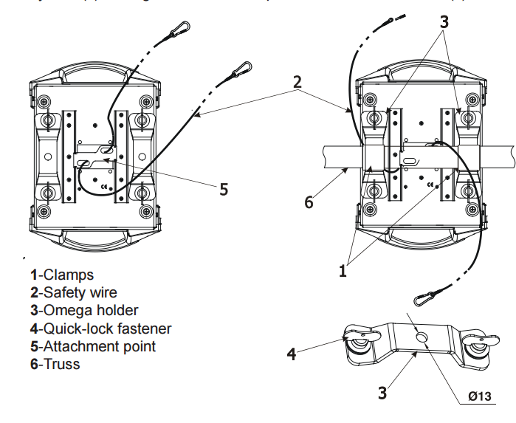

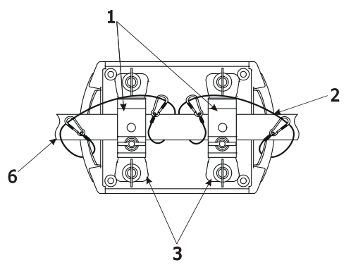
Alternatively, fixtures handles can be used for safety attachment

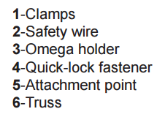

When installing fixtures side-by-side,
avoid illuminating one fixture with another!

DANGER TO LIFE!
Before taking into operation for the first time, the installation has to be approved by an expert!

4.4 DMX-512 connection
The fixture is equipped with both 3-pin and 5-pin XLR sockets for DMX input and output. The sockets are wired in parallel.
Only use a shielded twisted-pair cable designed for RS-485 and 3-pin or 5-pin XLR-plugs and connectors in order to connect the controller with the fixture or one fixture with another.

DMX - output
XLR mounting-sockets (rear view):
DMX - input
XLR mounting-plugs (rear view):

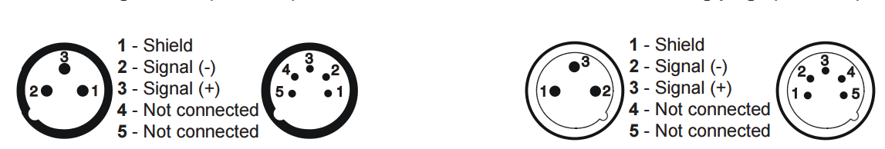

If you are using the standard DMX controllers, you can connect the DMX output of the controller directly with the DMX input of the first fixture in the DMX-chain. If you wish to connect DMX-controllers with other XLR-outputs, you need to use adapter-cables.

Building a serial DMX-chain:
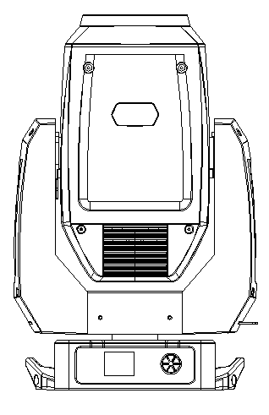
120Ω

DMX512

Connect the DMX-output of the first fixture in the DMX-chain with the DMX-input of the next fixture. Always connect one output with the input of the next fixture until all fixtures are connected.
Caution: At the last fixture, the DMX-cable has to be terminated with a terminator. Solder a 120 Ω resistor between Signal (–) and Signal (+) into a 3-pin XLR-plug and plug it in the DMX-output of the last fixture.

- Control menu map

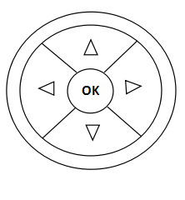
  - Button Instruction
S1：Return
S2：Down
S3：Enter
S4：UP

Menu Page:
- Address
2.Fixture Setting
3.Manual Setting
4.Auto Test
5.System Test
6.Information

  - Menu Function

When in Start Page, press any button, then reach the Selection Page



Main Menu | 1st Selection | 2nd Selection | Using Noted
Address | Address Setting |  | a) Press S3 enter to Selection Page;  b) Press S2 or S4 to change DMX address at range 1 to 512;  c) Press S3 to save and exit Select Page;  d) Press S1 to exit directly-without save the selection.
Fixture | Channel Mode | Standard Mode | Select “Channel Mode”  a) Press S3 enter to option selection Page;  b) Press S2 or S4 to select Channel Mode options;  c) Press S3 to save and exit selection Page;  d) Press S1 to exit directly-without save the selection.
Fixture | Channel Mode | Extend Mode
Fixture | Pan/Tilt Setting | Invert Pan | Select “Invert Pan/Tilt”  a) Press S3 enter to option selection Page;  b) Press S2 or S4 to select ON/Off options;  c) Press S3 to save and exit the selection Page;  d) Press S1 to exit directly-without save the selection.
Fixture | Pan/Tilt Setting | Invert Tilt
Fixture | Pan/Tilt Setting | Swap Pan-Tilt | Select “Swap Pan-Tilt”  a) Press S3 enter to option selection Page;  b) Press S2 or S4 to select ON/Off options;  c) Press S3 to save and exit at selection Page;  d) Press S1 to exit directly-without save the selection..
Fixture | Curve | Exp -Curve | Select “Curve”  a) Press S3 enter to option selection Page;  b) Press S2 or S4 to select Dimmer Curve options;  c) Press S3 to save and exit at selection Page;  d) Press S1 to exit directly-without save the selection.
Fixture | Curve | Linear
Fixture | Curve | Log-Curve
Fixture | Curve | S-Curve
Fixture | Reset | Head Reset | Select “Reset”  a) Press S3 enter to option selection Page;  b) Press S2 or S4 to select Reset options;  c) Press S3 to save and exit at selection Page;  d) Press S1 to exit.
Fixture | Reset | Pan/Tilt Reset
Fixture | Reset | All reset
Manual | Pan | 0-255 | Select “Channel”  a) Press S3 enter to channel selection Page;  b) Press S2 or S4 to select channel;  c) Press S3 to enter edit status;  d) Press S2 or S4 to change channel value from 0 to 255 at edit status;  e) Press S3 to save channel value and exit edit status;  f) Press S1 to exit edit status without save.
Manual | Tilt | 0-255
Manual | Dimmer | 0-255
Manual | Strobe | 0-255
Manual | Cyan | 0-255
Manual | Magenta | 0-255
Manual | Yellow | 0-255
Manual | Color1 | 0-255
Manual | Color2 | 0-255
Manual | Color3 | 0-255
Manual | Fixed -Gobo | 0-255
Manual | Rot-Gobo | 0-255
Manual | Rot-Gobo Rot | 0-255
Manual | Iris | 0-255
Manual | Prism1 | 0-255
Manual | Prism1 Rot | 0-255
Manual | Prism2 | 0-255
Manual | Prism2 Rot | 0-255
Manual | Frost | 0-255
Manual | Focus | 0-255
Manual | Zoom | 0-255
Run Mode | Stop |  | Select “Run Mode”  a) Press S3 enter to test program Page;  b) Press S2 or S4 to select test program options;  c) Press S3 to exit at selection UI with save and run selected test program;  d) Press S1 to exit without save .
Run Mode | Auto program 1
Run Mode | Auto program 2
Run Mode | Auto program 3
System | Backlight Setting | Auto | Select “Backlight Setting”  a) Press S3 enter to option selection Page;  b) Press S2 or S4 to select Backlight Setting options;  c) Press S3 to save and exit selection Page;  d) Press S1 to exit without save.
System | Backlight Setting | Keep On
System | Display | Normal | Select “Display”  a) Press S3 enter to option selection Page;  b) Press S2 or S4 to select Display options;  c) Press S3 to save and exit selection Page;  d) Press S1 to exit without save.
System | Display | Turnover
Language | Chinese
Language | Language

6. Technical Specifications
Electrical
Power supply:.........................electronic auto-ranging
Input voltage range:............... 100-240V, 50/60Hz
Max. Power consumption:.......500 W@230V
Fuse:.......................................8 A, 250V
Light source
200W white engine
Color temperature: 6500K
CRI=80
Color wheel
9 dichroic filters + open
CMY color mixing
Smooth CMY color mixing system

Static gobo wheel
7 metal gobos, image diameter = 22.5mm, aluminum, thickness = 0.5 mm. Gobo wheel continuous rotation
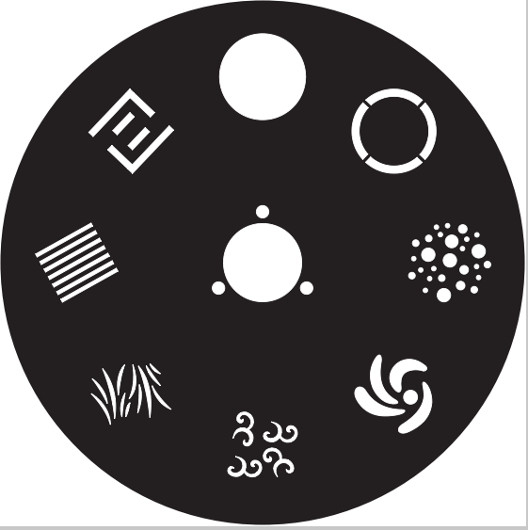
7
1

2
6

5
3

4

Rotating gobo wheel
7 glass gobos can be indexed and rotated in both directions at different speeds. Gobo wheel continuous rotation
Glass gobos: outside diameter=26.8 mm, max. thickness =4 mm, high temperature glass or better
"Slot & lock" system for easy replacement of gobos






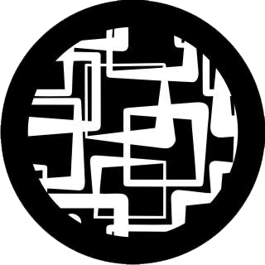
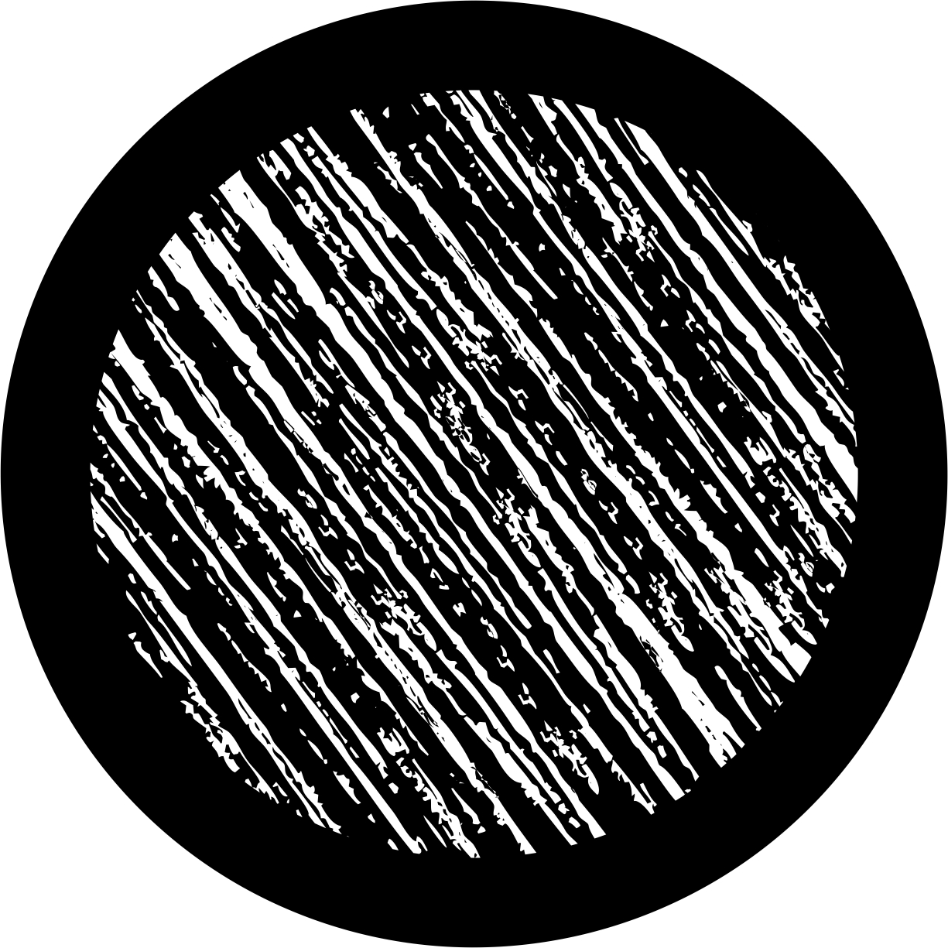

2
6
7
1
3
4
5

Warning!!!
All glass Gobos which are changed, must be supplied from the original factory. These glass gobos are professional heat-resistant glass gobos. No warranty is provided for altered gobos.

Prism
Rotating 3-facet 11° prism with continuous rotation in both directions，Rotating 8-facet 12° prism with continuous rotation in both directions，prism indexing.

Iris
Motorized iris for different beam diameters

Zoom
Linear motorized zoom (5°- 42°)

Strobe
Strobe effect with variable speed (max.15 flashes/sec.)

Dimmer
Smooth dimmer from 0 - 100 %

Control
Readout fixture and light source usage, receiving DMX values, temperatures, etc
Built-in analyzer for easy fault finding, error messages
Built-in demo sequences
Black-out while head moving, color changing
Silent fans cooling,

Optional Wireless DMX/RDM module
Compliance with USITT DMX-512 (1986 & 1990) and 512-A
Full DMX fidelity and frame integrity
Auto sensing of DMX frame rate and frame size
<5ms DMX latency
Operational frequency range of 2402-2480 MHz

Pan/Tilt
Pan movement range 540°
Tilt movement range 270°
16 bit movement resolution

Rigging
Mounting points: 2 pairs of 1/4-turn locks
Mounting horizontally or vertically via 2 Omega brackets

Temperatures
Maximum ambient temperature: 45° C
Maximum housing temperature: 80° C

Minimum distances
Min. distance from flammable surfaces: 0.5 m
Min. distance to lighted object: 2 m

Weight (net) 22 kg

Dimensions (mm)
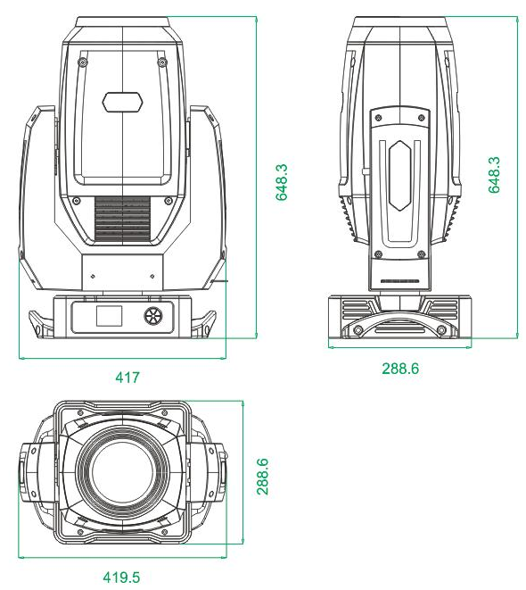

- Maintenance and cleaning
It is absolutely essential that the fixture is kept clean and that dust, dirt and smoke-fluid residues must not build up on or within the fixture. Otherwise, the fixture‘s light-output will be significantly reduced. Regular cleaning will not only ensure the maximum light-output, but will also allow the fixture to function reliably throughout its life. A soft lint-free cloth moistened with any good glass cleaning fluid is recommended, under no circumstances should alcohol or solvents be used!
DANGER!
Disconnect from the mains before starting any maintenance work

The front objective lens will require weekly cleaning as smoke-fluid tends to building up residues, reducing the light-output very quickly. The cooling-fans should be cleaned monthly.
The interior of the fixture should be cleaned at least annually using a vacuum cleaner or an air-jet. Dichroic color filters, gobo wheels and the internal lenses should be cleaned monthly.
Remove dust and dirt from the fans and cooling vents using a soft brush and a vacuum cleaner.
Important!
Check the air filters periodically and clean before they become clogged!

Clean the air filters placed in the fixture bases. Use a vacuum cleaner, compressed air or you can wash them and put back dry.
After replacing the air filters, reset the elapsed time counter in the menu "Information" (Information--->Air Filters---> Elapsed Time).

Replacing the fuse.
Before replacing the fuse, unplug mains lead.
- Remove the fuse holder on the rear panel of the base with a fitting screwdriver from the housing (anti-clockwise).
- Remove the old fuse from the fuse holder.
- Install the new fuse in the fuse holder (only the same type and rating).
- Replace the fuse holder in the housing and fix it.

12.1 Disposing of the product
To preserve the environment, please dispose or recycle this product at the end of its life according to the local regulations and codes.

- Photo metric diagram
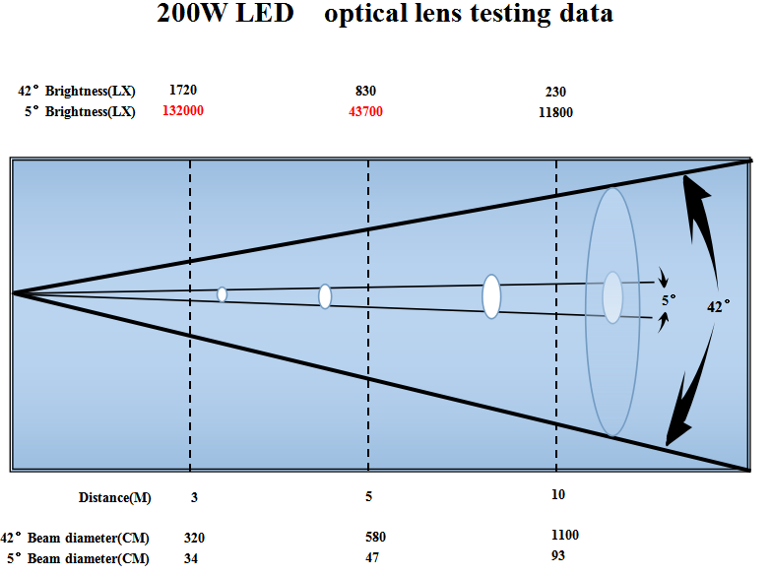

Extreme 350 DMX Channels
Mode/Channel |  | Value | Function
Ba | St | Value | Function
1 | 1 |  | Pan
1 | 1 | 0-255 | 0-100%
2 | 2 |  | Pan fine
2 | 2 | 0-255 | 0-100%
3 | 3 |  | Tilt
3 | 3 | 0-255 | 0-100%
4 | 4 |  | Tilt fine
4 | 4 | 0-255 | 0-100%
5 | 5 |  | Pan/Tilt Speed
5 | 5 | 0-255 | Fast -> Slow
6 | 6 |  | Dimmer
6 | 6 | 0-255 | 0-100%
 | 7 |  | Dimmer fine
 | 7 | 0-255 | 0-100%
7 | 8 |  | Strobe/Shutter
7 | 8 | 0-3 | Close
7 | 8 | 4-103 | Strobe, Slow -> Fast
7 | 8 | 104-107 | Open
7 | 8 | 108-207 | Pulse: Slow -> Fast
7 | 8 | 208-212 | Open
7 | 8 | 213-251 | Random
7 | 8 | 252-255 | Open
8 | 9 |  | Cyan
8 | 9 | 0-255 | 0-100%
9 | 10 |  | Magenta
9 | 10 | 0-255 | 0-100%
10 | 11 |  | Yellow
10 | 11 | 0-255 | 0-100%
11 | 12 |  | Color1
11 | 12 | 0-255 | 0-100%
12 | 13 |  | Color2
12 | 13 | 0-255 | 0-100%
13 | 14 |  | Color3
13 | 14 | 0-255 | 0-100%
14 | 15 |  | Static Gobo
14 | 15 | 0-9 | Blank
14 | 15 | 10-19 | Gobo 1
14 | 15 | 20-29 | Gobo 2
14 | 15 | 30-39 | Gobo 3
14 | 15 | 40-49 | Gobo 4
14 | 15 | 50-59 | Gobo 5
14 | 15 | 60-69 | Gobo 6
14 | 15 | 70-79 | Gobo 7
14 | 15 | 80-89 | Gobo 1 Shake: Slow -> Fast
14 | 15 | 90-99 | Gobo 2 Shake: Slow -> Fast
14 | 15 | 100-109 | Gobo 3 Shake: Slow -> Fast
14 | 15 | 110-119 | Gobo 4 Shake: Slow -> Fast
14 | 15 | 120-129 | Gobo 5 Shake: Slow -> Fast
14 | 15 | 130-139 | Gobo 6 Shake: Slow -> Fast
14 | 15 | 140-149 | Gobo 7 Shake: Slow -> Fast
14 | 15 | 150-202 | Rotation(CW): Fast -> Slow
14 | 15 | 203-255 | Rotation(CCW): Slow -> Fast
15 | 16 |  | Rotating Gobo
15 | 16 | 0-9 | Blank
15 | 16 | 10-19 | Gobo 1
15 | 16 | 20-29 | Gobo 2
15 | 16 | 30-39 | Gobo 3
15 | 16 | 40-49 | Gobo 4
15 | 16 | 50-59 | Gobo 5
15 | 16 | 60-69 | Gobo 6
15 | 16 | 70-79 | Gobo 7
15 | 16 | 80-89 | Gobo 1 Shake: Slow -> Fast
15 | 16 | 90-99 | Gobo 2 Shake: Slow -> Fast
15 | 16 | 100-109 | Gobo 3 Shake: Slow -> Fast
15 | 16 | 110-119 | Gobo 4 Shake: Slow -> Fast
15 | 16 | 120-129 | Gobo 5 Shake: Slow -> Fast
15 | 16 | 130-139 | Gobo 6 Shake: Slow -> Fast
15 | 16 | 140-149 | Gobo 7 Shake: Slow -> Fast
15 | 16 | 150-202 | Rotation(CW): Fast -> Slow
15 | 16 | 203-255 | Rotation(CCW): Slow -> Fast
16 | 17 |  | Gobo Rotating
16 | 17 | 0-127 | Gobo Position
16 | 17 | 128-191 | Gobo Rotation(CW): Fast->Slow
16 | 17 | 192-255 | Gobo Rotation(CCW): Slow-> Fast
 | 18 |  | Gobo Rotating index fine
 | 18 | 0-255 | 0-100%
17 | 19 |  | Focus
17 | 19 | 0-255 | 0-100%
 | 20 |  | Focus fine
 | 20 | 0-255 | 0-100%
 | 21 |  | Auto focus
 | 21 | 0-55  56-105  106-155  156-205  206-255 | Auto Focus Disable  Auto Focus 3m  Auto Focus 5m  Auto Focus 10m  Auto Focus 15m
18 | 22 |  | Zoom
18 | 22 | 0-255 | 0-100%
 | 23 |  | Zoom fine
 | 23 | 0-255 | 0-100%
19 | 24 |  | Prism1
19 | 24 | 0-127 | Prism 1 out
19 | 24 | 128-255 | Prism 1 in to the light beam
20 | 25 |  | Prism1 Rotate
20 | 25 | 0-127 | 0-100%
20 | 25 | 128-191 | Rotation(CW): Fast -> Slow
20 | 25 | 192-255 | Rotation(CCW): Slow -> Fast
21 | 26 |  | Prism2
21 | 26 | 0-127 | Prism 2 out
21 | 26 | 128-255 | Prism 2 in to the light beam
22 | 27 |  | Prism2 Rotate
22 | 27 | 0-127 | 0-100%
22 | 27 | 128-191 | Rotation(CW): Fast -> Slow
22 | 27 | 192-255 | Rotation(CCW): Slow -> Fast
23 | 28 |  | Iris
23 | 28 | 0-255 | 0-100%
24 | 29 |  | Frost
24 | 29 | 0-255 | 0-100%
25 | 30 |  | Reset
25 | 30 | 0-31 | Unused
25 | 30 | 32-63 | Pan/Tilt Reset
25 | 30 | 64-95 | Head Reset
25 | 30 | 96-127 | Complete Reset
25 | 30 | 128-159 | Reserved
25 | 30 | 160-191 | Reserved
25 | 30 | 192-223 | Reserved
25 | 30 | 224-255 | Reserved

If you have any questions, please contact your local dealer.

